Marlowe park medical Centre
Friends and Family Test 2015/ 2016
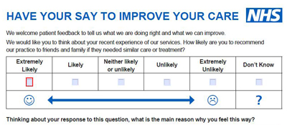

The questionnaire is placed at reception and patients are invited to fill in and place answer into a sealed box.
The graph below shows the results complied since April2015

