Are you living with diabetes?

The Diabetes UK Medway Support Group would like to invite you an evening of Diabetes Support

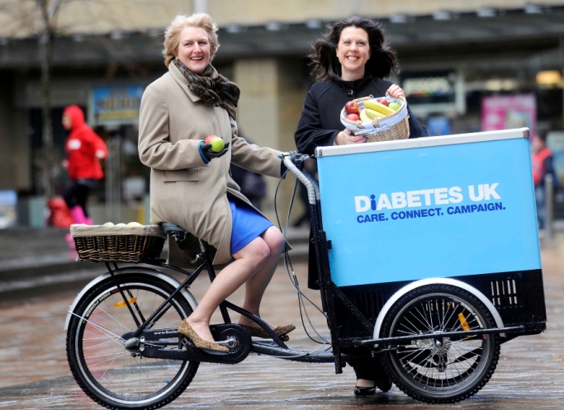

Date: Monday 24th November 2014 7pm – 9pm
Location: St Paul’s Church Hall, Parkwood Green, Rainham, Gillingham ME8 9PN

The Event
We would like to welcome you to our open evening so that you can find out more about living with diabetes and our local support.
We are pleased to welcome a Michaela Wragg, Volunteer Development Support Officer from Diabetes UK.
This is our last meeting for this year so we will also have a quiz, music and seasonal refreshments. We look forward to welcoming you!!

The event is free to attend. For more information
Please visit our web pages at http://medwayvoluntarygroup.diabetesukgroup.org/home/home.asp
Or alternatively
Karen on 07725 238 464
or email medwaydiabetessupport@hotmail.co.uk
This mailing has been sent by Diabetes UK on behalf of the Diabetes UK Medway Support Group. Diabetes UK takes data protection very seriously. We will not pass your details on to other organisations. If you do not wish to receive further mailings from Diabetes UK about our work and that of our trading company, please contact Diabetes UK.

