Survey results based on 88 patients.

The survey was available in the reception area for patients to complete

Knowledge and awareness of what the practice offers

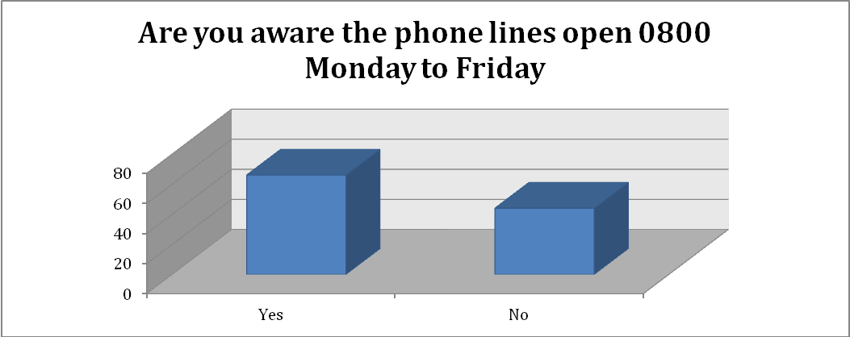

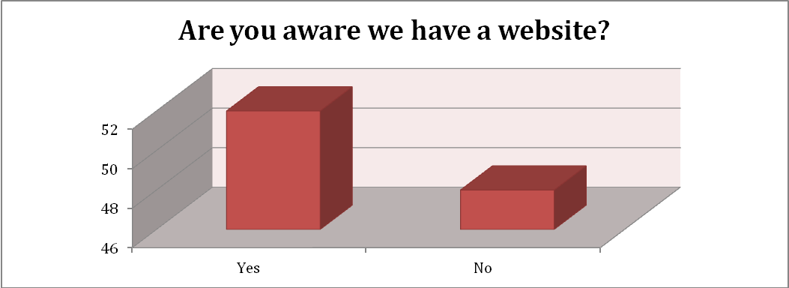

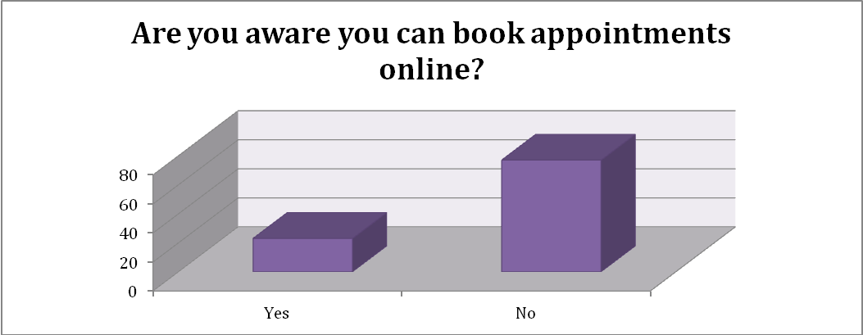

Thinking of your recent consultation with your doctor, how do you rate the following?

Thinking of your recent consultation with your nurse, how do you rate the following?

Personal Details

