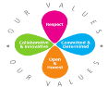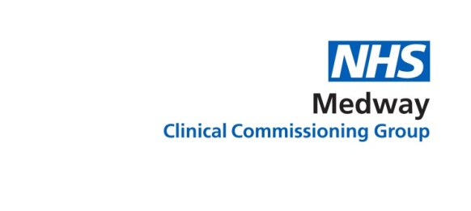

Improving Adult Community Health Services in Medway – Public Engagement Autumn 2018

Dear colleague,

Over the last year Medway Clinical Commissioning Group has been working with local people, patients, clinical staff and Medway Council to see how we can improve adult community health services to keep people well and cared for closer to home.

This autumn we are carrying out a programme of public engagement looking at our proposals for these services and the changes we are planning to make.

The engagement will run from September 3rd to October 26th 2018. We will publish a document summarising our proposals together with background materials, run a survey and hold a series of meetings, focus groups and discussions.

Adult community health services are provided in community settings, including in people’s homes. Our aim is to reconfigure these services so that they are less fragmented and more joined-up, so that more of them are provided closer to people’s homes and with improved access hours.

We will be holding three public meetings to discuss our proposals and you are warmly invited to attend one of these. Please register your interest at the links provided.

Thursday 20th September, 18:30 – 20:30 (18:00 registration), Priestfield Stadium, Redfern Avenue, Medway, ME7 4DD: https://communityservicesreview-priestfield.eventbrite.co.uk

Monday 8th October, 18:30 – 20:30 (18:00 registration), Holiday Inn Maidstone Road, Rochester ME5 9SF: https://adultcommunityservices-rochester.eventbrite.co.uk

Friday 19th October, 10:30 – 12:00, Rainham Bereavement Group, St Margaret's Millennium Centre, Gatekeeper Chase, Rainham ME8 9BH:
https://adultcommunityservices-stmargaretsmilleniumcentre.eventbrite.co.uk

I will be writing to you in early September when we publish our proposed changes and launch our engagement. Information on adult community health services and the engagement we have conducted so far can be found here.

If you have any questions about the engagement please email medway.communications@nhs.net or phone 01634 335260. I look forward to seeing you at one of our meetings.

Yours

Dr Farnaaz Sharief MBE
Elected Clinical Member Governing Body
NHS Medway Clinical Commissioning Group

